From the Sett
The Basildon Badgers Newsletter

Hello, welcome to issue 4 of ‘from the Sett’ and Merry Christmas from all of us at Basildon Badgers! In this issue we revisit November’s matches, introduce our newly formed Under 16’s, share badger of the month, set our first competition and offer up the usual photos, admin and notices..

Christmas Party
Thanks to everyone who came along to our Christmas party at the Red Lion and we hope you had a great time. We raised £300 and have a number of shirts for the Kitmas charity. On that note, if you have an old football shirt there’s still time to pass it on – please get in touch. Thanks also to our very generous prize donators who gave the raffle a real boost: Cakery Bakery, PR Motors, Plan B fitness, the Orchard Clinic, Huffy bikes and of course the Red Lion who also did a brilliant job with the catering.

Team Updates – November / December
We kicked off November with the U10’s marching on at the top of the league thanks to a 4-3 away win at Barton Rovers. We didn’t know it at the time but the last-minute winner they scored was enough to seal the 4th Division Title as teams only play each other once due to rules around competitive fixtures for U10 players. They’ve taken that form into the friendlies that followed with more wins and an exciting 3-3 draw over at Newbury against CSA who play a division up and offered a taste of what’s to come next season. The game marked the first match on the new town centre pitch; as a result the players got a medal and a mention here:
https://newbury.gov.uk/news/great-turnout-for-return-of-football-at-victoria-park/

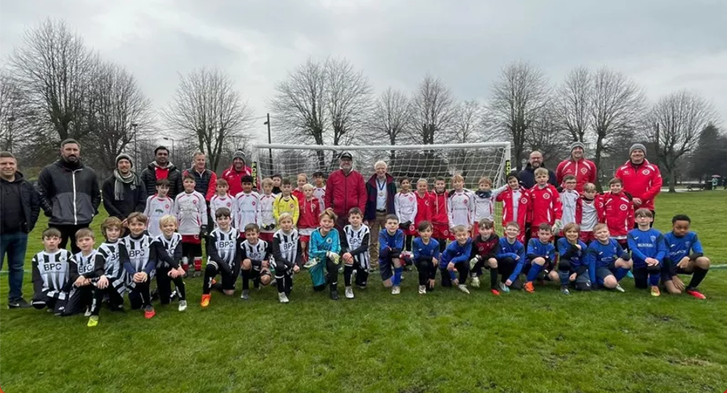

Elsewhere our U11’s finished their season in 4th place in Division 1 following another great campaign. Having qualified for the knockout semi-final (the top four qualified) they played a one off match against FC Tekkers and eventually lost out 3-0. They’ve been brilliant to watch though and we look forward to more good stuff from them!

Our U8’s march on with ‘Badgers’ continuing their unbeaten run which extends back into last season. Our ‘stripes’ team continues to improve too and have put in some real battling performances over the last few months and often deserved more than they got. They’ll both be moving onto futsal shortly before returning to league action in the Spring.

Finally our Under 7’s have continued to have fun and play their part in some amazing games. Of note was a 7-5 defeat to Newbury which witnessed an under two minute hat trick by Arthur coupled with two great performances against Barton Rovers and Calcot Royals. Thanks to all of those who have spread the word which has led to three new players joining; the team is looking good and we look set for the rest of the season.
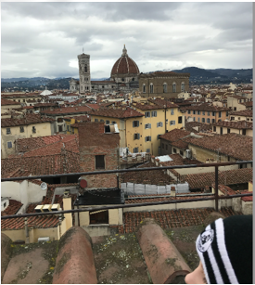
World Wide Badgers
Going on holiday? Doing something unusual or planning on bumping into someone ridiculously famous?Send us a photo of you (or your child) in a Badgers shirt/top/hat/coat/whatever and the coaches will pick a winner (and come up with a prize) at the end of the season. Here’s your starter – Florence, Italy and one Badgers woolly hat:

Fundraising
We’ve been really lucky this season to have received support from a variety of sources. Towards the end of November was another unexpected bonus with a grant of £300 from the Country Neighbour who each year donate any profits they’ve made to various groups and/or charities. Most of you will be aware that we sail a little (lot) close to the wind with finances in a bid to offer football as cheaply as possible so nice surprises like this really make a difference and we’re very grateful to Brian and the rest of the Country Neighbour team for thinking of us. We’ll be using the money to offset some of our U7 costs and part fund the general kit for use by our older teams including the U16’s which has just been reformed (they are in the wintery U9s photo below!!).
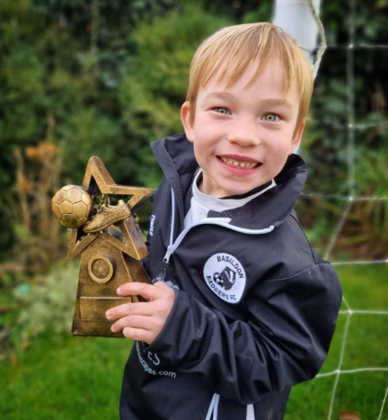
Badger of the Month – our latest winner
The local Badger Trust (Binfield branch) kindly sponsor our Badger of the Month award for the player or coach who has really stepped up and gone ‘above and beyond’. This month our winner is Sam (U8). He is always first to volunteer to play in goal and when he feels the games are tight, he often has a second go in goal. He is a great striker, battles hard up front to win the ball and hold it up. He has scored some great goals including against CSA in his most recent match. Well done Sam.
Team in focus – U16’s
We’ve had a new addition to our teams with the formation of an Under 16’s group made up of former players (see U9s below) and friends who are keen to continue their involvement with the club. They’re affiliated with the FA and are now training a couple of times a month on a Saturday afternoon at the recreation ground. There is space for anyone in either year 10 or 11 (and possibly 12) with the hope that they’ll play the odd friendly and enter tournaments as the weather picks up. They will stay out of leagues at least this season as most play for various sides across Berkshire and Oxfordshire but the long term hope is to use this as a spring board to an eventual adult side.
If you know anyone who’d like to get involved please contact us at basildonbadgersfc@outlook.com. We’ll stick up some photo’s once they’re settled and competing….

From the Archive….
Here’s the U9’s competing in the clubs first ever fixture back in December 2016 at the Eldon Celtic winter tournament on 3G. Note the heavy frost which is why we picked the photo! The team lost 3-1 but we did score our first competitive goal thanks to Jack Badham who now helps out on a Saturday and is getting involved with our newly put together U16 side. It was even colder than it looks….

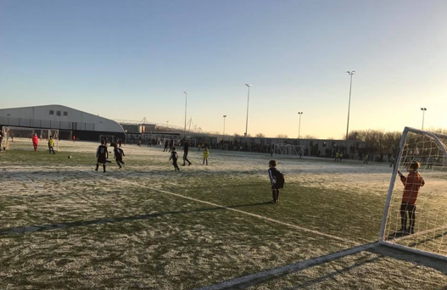

Admin Corner…… Useful links, club directory and positions vacant….

Boots, Recycling and Kit
There are tons of boots as you probably know and these range from 11 to adult sized 6. All boots are free to players/siblings and if you’ve any old boots or kit you’d like us to take please get in touch with Rob on a Saturday morning at the gazebo or via any of the coaches.
We’ve also a couple of coats that are available for free and three new old stock ones (Medium / Large) going for £10 each. These are very warm and had received rave reviews so feel free to pop over and try one on….

Upcoming fixtures
Coaches will advise of futsal / outdoor fixtures as they receive them and we’ll kick off the fixture matrix again as the weather improves and we return to outside fixtures.

Useful links & Info:
Our emergency guidelines (access for ambulance, defibrillator etc) are printed on the inside door of our main cupboard should they be required. If you’ve a Safeguarding or Welfare issue, please report it to Rob robertgreasley@hotmail.com.

Our kit supplier can be found here:
https://basildon-badgers.pendlesportswear.co.uk/replica-products/football-training-wear/

Our local league:
https://fulltime.thefa.com/index.html;jsessionid=34547AAB70C2D40F3DA47AEB1D6EC21F?selectedSeason=770559162&selectedFixtureGroupAgeGroup=16&selectedDivision=162278091&selectedCompetition=0
Click on ‘Age Group’ (middle of the page) and you’ll see upcoming fixtures and (for older groups) current league tables and statistics.

Club Directory
Here's who’s who at the club, the lead for each group is marked in Italics:
U7 Coach – Melanie, Nancy, Holly, James, Andy, Lucy
U8 Coach – Ben, Laura, Miz, Matt
U10 Coach – Andy, Jon, Ash
U11 Coach Darren, Chris
U12/13 Coach – Mark, Rupert, Jack
Treasurer - Melanie
Chairman / Safeguarding (Welfare) – Rob
Secretary - Paul
Catering (tea hut) & Saturday Admin– Leonora, Rob

We’re always looking for help; the more we get the more teams we can have – please get in touch if you fancy trying something different!

